Assessment Schedule – 2014

Science: Demonstrate understanding of aspects of mechanics (90940)

Evidence Statement
ONE | Evidence |  |  | Achievement |  | Merit |  | Excellence
(a) | F = m × g = 99 × 10 = 990 N |  |  | Shows correct process.
(b)(i) | Section A: Increasing speed / accelerating  Section B: Constant speed  Section C: Decreasing speed, decelerating  Section D: Stopped / stationary |  |  | Describes TWO sections correctly. |  | Describes THREE out of four sections correctly AND calculates speed with unit.
(ii) | 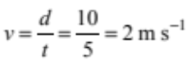 |  |  | Calculates speed correctly.  (unit is not required)
(c) | F = 20 × 10 = 200 N  W = F × d = 200 × 1.5 = 300 J  P = W / t = 300 / 3 = 100 W |  |  | Correct calculation of weight force.  (unit is not required) |  | Correct calculation of work.  (unit is not required) |  | Correct calculation of power. (wrong unit for one minor error (OMI))
(d) | As the height above the ground is the same, the same work is required to travel up the ramp as lifting the bike straight up. If the same amount of work is done, the same amount of energy is gained.  As W = F × d, if d is increased, the amount of force required to do the same amount of work will be less, ie a ramp allows the same amount of work to be done with a smaller force over a greater distance.  OR  Going up the ramp, the push force required is against a component of the gravity force of the bike. A vertical lift would require a push equal to to gravity force. Therefore the force required to lift the bike straight up is greater than the force required to push it up the ramp.  The energy gained by the bike is the same in both cases, but the time taken to go up the ramp is greater than lifting it vertically. As P = W / t, a greater time would mean less power is required. |  |  | ONE of:  - Same amount of work done (energy gained), regardless of length.  - Less force is needed to push up the ramp OR more force to lift up.  - Less power is needed to push up the ramp (not less energy).  - More time taken to push up the ramp OR less time to lift straight up. |  | ONE of:  - Explains that a ramp allows same / similar amount of work / energy with smaller force.  - Less power needed to push up the ramp, as it takes longer.  - It is easier, as the work is spread over a longer time.  - More power needed to lift, as energy is used all at once. |  | ONE of:  - Explains why a ramp requires less force than lifting straight up. ( or vice versa)  - Discuss energy (and force), correctly relates power to time taken.  (same/similar work /energy is required)
N0 |  | N1 | N2 | A3 | A4 | M5 | M6 | E7 | E8
No response OR response does not relate to the question. |  | ONE idea from Achievement. | TWO ideas from Achievement. | THREE ideas at the Achievement level. | FOUR ideas from Achievement. | TWO points from Merit. | THREE points from Merit. | TWO points from Excellence; minor error in calculation. | TWO points from Excellence.

TWO | Evidence |  |  | Achievement |  | Merit |  | Excellence
(a) | 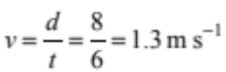 (do not accept 1.4 without working) |  |  | Calculates velocity.  (Do not penalise wrong unit)
(b) | Statement B  There is less friction on the wooden floor, so it takes less force to push the footstool on this surface.  OR  There is more friction on carpet so it takes more force to push the footstool on this surface. |  |  | Identifies statement B and mentions friction (or equivalent) in response. |  | Statement B AND explains why there is less friction on the wooden floor than the carpet and it takes less force / effort / energy (work) to push.
(c) | Surface area of the chair legs:  4 × 0.001 = 0.004 m²  Weight of chair:  F_{w} = m × g = 15 × 10 = 150 N  Pressure exerted:  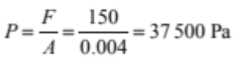 (Nm⁻²) |  |  | Calculates weight force of chair  OR  Calculates surface area for 4 legs. |  | Calculates pressure for one chair leg, ie:  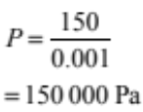 |  | Calculates pressure for all 4 chair legs with the correct unit, ie:  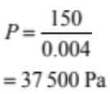  (wrong unit for OMI)
(d) | The footstool has a much larger surface area in contact with the floor than the chair. The force applied to both the chair and the footstool are the same because the same person sits on both.  P = F / A, so if A is bigger then the pressure must be smaller (or vice versa).  Note: weigh the same is not acceptable |  |  | Marks in carpet are less because the footstool has a larger surface area. |  | Explains that if the surface area is bigger, then pressure exerted is smaller (or vice versa for smaller chair legs). |  | Links pressure exerted to surface area (P = F / A) and explains same force applied to both and relates to marks on carpet.
N0 |  | N1 | N2 | A3 | A4 | M5 | M6 | E7 | E8
No response; no relevant evidence. |  | ONE idea from Achievement. | TWO ideas from Achievement. | THREE from Achievement. | FOUR ideas from Achievement. | TWO points from Merit, | THREE points from Merit. | TWO points from Excellence; minor error in calculation. | TWO points from Excellence.

THREE | Evidence |  |  |  | Achievement |  | Merit |  | Excellence
(a) | W = F × d = 6 000 × 50 = 300 000 J |  |  |  | Calculates work. (no unit required)
(b) | Work is done when a force causes the beam to move in a direction of the force. The force is not causing the object to move, so no work is being done.  (No distance travelled in the direction of the force) |  |  |  | Identifies that there is no motion (or no force causing the object to move), so no work done. |  | Explains how the motion of the beam is affected by the forces acting on the beam.
(c) | Explanation of energy difference:  At the top, the wood has a certain amount of gravitational potential energy and no kinetic energy.  Just before the wood hits the ground, the gravitational potential energy has been converted into kinetic energy.  E_{P} calculation:  E_{P} = mgh = 150 × 10 × 12 = 18 000 J  Difference between E_{P} and E_{K}:  = 18 000 – 15 000 = 3 000 J  Energy loss:  Some kinetic energy is lost as heat energy due to the frictional force of air resistance. |  |  |  | - Identifies gravitational potential energy being present when the wood is hanging.  - Recognises that the energy difference is due to air resistance / friction.  - Calculates E_{P}.  - Identified energy lost as heat or sound |  | - Calculates E_{P} and the difference in energy (unit not required)  - Shows understanding of concepts and principles of energy conservation and explaining the “missing” energy is loss due to friction with the air/air resistance OR lost as heat (sound). |  | - Calculates E_{P} and the difference in energy correctly (no unit OMI)  - Connects the justification for the difference in energy between the top and bottom positions with the relevant physics principles, discussing frictional forces due to air resistance causing energy loss as heat.  (minor error if the term air resistance / friction is implied but not properly / directly used)
N0 |  | N1 | N2 | A3 |  | A4 | M5 | M6 | E7 | E8
No response; no relevant evidence. |  | ONE idea from Achievement. | TWO ideas from Achievement. | THREE from Achievement. |  | FOUR ideas from Achievement. | TWO points from Merit, | THREE points from Merit. | TWO points from Excellence; One Minor Error only | TWO points from Excellence.

FOUR | Evidence |  |  |  | Achievement |  | Merit |  | Excellence
(a) | 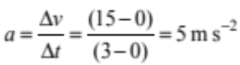 |  |  |  | Calculates acceleration.
(b)(i) | 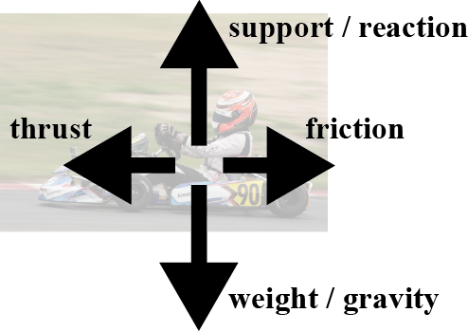 |  |  |  | States / draws one pair of forces and shows or states their relative size.  (Evidence could come from (ii).)
(ii) | Weight and support are equal and opposite. (evidence can come from b (i) )  Thrust and friction are equal and opposite.  The go-cart is moving with a constant speed, meaning that the acceleration is zero. If acceleration is zero, the net force must also be zero. This means that all the forces acting are balanced. Forces are balanced and therefore F_{net} = 0. |  |  |  | Section B has constant speed.  OR  all the forces are balanced/net force = 0 |  | - Both pairs of forces are balanced as they are equal and opposite.  - Balanced forces / 0 net-force resulted constant speed in this case (no acceleration). |  | Shows an understanding of how the F_{net} = 0 is connected with the constant speed AND no acceleration in Section B of the graph.  (not necessarily have to explain the vertical pair)
(c) | Distance Francis has covered  Area under the graph is:  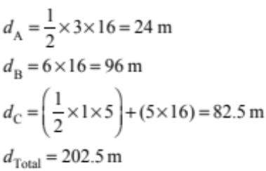 |  | Distance Zane has covered  Area under the graph is:  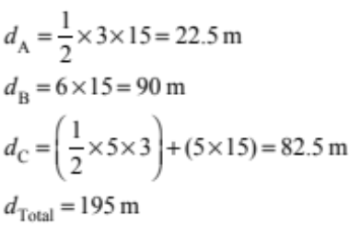  Francis travelled the greater distance. |  | Calculates the distance travelled for ONE section (for either Francis or Zane). |  | Completes the calculations accurately for each section for one of the two racers.  OR  For any four sections.  OR  Correct answer for both racers and conclusion without working shown. |  | Compares the two distances travelled in 14 s correctly, and is therefore able to say that Francis is the only rider to have travelled over 200 m around the track after 14 s (or vice versa).
N0 |  | N1 |  | N2 | A3 | A4 | M5 | M6 | E7 | E8
No response; no relevant evidence. |  | ONE idea from Achievement. |  | TWO ideas from Achievement. | THREE from Achievement. | FOUR ideas from Achievement. | TWO points from Merit. | THREE points from Merit. | ONE point from Excellence | TWO points from Excellence.

Cut Scores
 | Not Achieved | Achievement | Achievement with Merit | Achievement with Excellence
Score range | 0 – 10 | 11 – 18 | 19 – 25 | 26 – 32

